**Chapter 9- OOP, Classes, and Objects**

**(2) Two programming challenges each worth 10 points**

**9.1 (THE RECTANGLE CLASS)**Following the example of the **Circle** class in [**Section 9.2**](https://jigsaw.vitalsource.com/books/9780136801504/epub/OPS/xhtml/fileP7001017159000000000000000005759.xhtml#P7001017159000000000000000005759), design a class named **Rectangle** to represent a rectangle. The class contains:

* + Two **double** data fields named **width** and **height** that specify the width and height of the rectangle. The default values are **1** for both **width** and **height**.
  + A no-arg constructor that creates a default rectangle.
  + A constructor that creates a rectangle with the specified **width** and **height**.
  + A method named **getArea()** that returns the area of this rectangle.
  + A method named **getPerimeter()** that returns the perimeter.

Write a test program that creates two **Rectangle** objects—one with width **4** and height **40**, and the other with width **3.5** and height **35.9**. Display the width, height, area, and perimeter of each rectangle in this order.

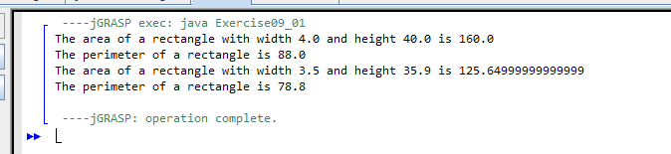

1. **9.2 (THE STOCK CLASS)**Following the example of the **Circle** class in [**Section 9.2**](https://jigsaw.vitalsource.com/books/9780136801504/epub/OPS/xhtml/fileP7001017159000000000000000005759.xhtml#P7001017159000000000000000005759), design a class named **Stock** that contains:
   * A string data field named **symbol** for the stock’s symbol.
   * A string data field named **name** for the stock’s name.
   * A **double** data field named **previousClosingPrice** that stores the stock price for the previous day.
   * A **double** data field named **currentPrice** that stores the stock price for the current time.
   * A constructor that creates a stock with the specified symbol and name.
   * A method named **getChangePercent()** that returns the percentage changed from **previousClosingPrice** to **currentPrice**.

Write a test program that creates a **Stock** object with the stock symbol **ORCL**, the name **Oracle Corporation**, and the previous closing price of **34.5**. Set a new Set a new current price to 34.35 and display the price-change percentage.

